print (“Hello World”)

Variables
Variables save the data in key:value pair.

Acceptable variables:
CamelCase
Snake_Case_Variable
numb3rsOk4yAfter1st

Not acceptable variables:
4callingbirds
not okay
$please.avoid!?

Data-types
Integers
int_1 = 7
int_2 = -52
int_3 = 0
int_4 = 900
int_5 = -749

Floating-Point Numbers:
float_1 = 1.2345
float_2 = -1.25
float_3 = 0.0
float_4 = 13.0
float_5 = -0.5

Booleans
bool_1 = True
bool_2 = False

Variables and Assignment Exercises. Do all of this in a .py file in Pycharm
- create a variable and assign it an integer
- create a second variable and assign it a float
- create a third variable and assign it a Boolean value
- re-assign a different integer to the first variable you created

Variables and Assignment Exercises Solution
integer = 7
float_num = 2.718
bool_val = False
integer = 10

Comments
Anything that is written after # is considred as comment in python and code will not consider it.

#in the below line, I have defined this and that.

Expressions and basic maths operators
addition = 4 + 5
subtraction = 5 -2
division = 9/3
multiplication = 4 * 5

exponentiation = 4**4
#4 x 4 x 4 x 4 = 256

floor_division = 16 // 5
# 16 / 5 = 3.5 = 3 Converts floating numbers into integer

modulo = 7 % 3
# When you will devide 7 with 3 the reminder is 1. So its answer would be 1.

Assignment Operators:
add_assign = 5
add_assign = add_assign + 7
add_assign = 12

sub = 10
sub -= 5
# 10 - 5 = 5

mult = 10
mult *= 5
# 10 x 5 = 50

div = 10
div /= 5
#10 / 5 = 2

exp = 10
exp **= 2
#10 x 10 = 100

floor = 10
floor //=6
#10 / 6 = 1.667 = 1

mod = 10
mod %= 7
#10 / 7 reminder is 3.

Comments and Math Operators Review Exercises
- Create a variable and assign it the sum of two integers
- Create a variable and assign it the difference of two integers
- Create a variable and assign it the result of one integer being divided by another integer
- Create a variable and assign it the product of two integers
- Create a variable and assign it the result of 3 raised to the 8th power
- Create a variable and assign it the result of 10 floor division 3
- Create a variable and assign it the integer 2 using the expression 17 modulo [number]

Print

example1 = 94281
example2 = “Hello World”
example3 = “It’s 3:15”

print(example1)
print(example2)
print(example3)

If you want that after the total of floating integers values, you get 2 numbers after the point you shoud start with round and then two brackets. But, after closing the one bracket and before closing the second bracket, you should mention the number of which you want after the point.

pasta = 16.68
sauce = 6.98
garlic = 16.78
seasoning = 15.26
bread = 3.00
meatballs = 4.39
subtotal = round((pasta + sauce + garlic + seasoning + bread + meatballs), 2)
print(subtotal)

String
- String is a sequence of characters.
- Those characters can be any combination of numbers, space, uppercase letters, lowercase letters, underscores or symbols.
- String are always defined in the single or double quote.
Ex.1
Faraz = “My name is Faraz”
print(Faraz)

My name is Faraz.

Ex.2
Faraz = “”
print(Faraz)

In a strung each character is assigned a number called an index number or index for short.
Ex.
Faraz = “0123456”

That means the seven characters string shown in this example has seven index numbers.
In python the index number starts with 0.
Index numbers start from left to right.

Ex.
Faraz = “My name is Faraz What is Yours?”
print(Faraz[9])

String Slicing
- String slicing allows you to get slices of a string and assign them to variables or print them.
- Here, slice of a string is just a string that was originally part of another string.

Faraz = “My name is Faraz What is Yours?”
print(Faraz[11:16])

Faraz

Faraz = "My name is Faraz What is Yours?"
print(Faraz[11:])

Faraz What is Yours?

Concatenation
- In concatanation, the addition operator is used to concatenate three strings.

Faraz = "My name is" + " " + "Faraz"
print(Faraz)

My name is Faraz

- You are probably wondering if accessing characters by index or string slicing change strings that have been assigned to variables. The answer is that they don't.

unchanged = "Forest gump"
sliced = unchanged[6:]
print(sliced)
print(unchanged)

gump
Forest gump

String Exercise
to_slice = "Just do it!"
print(to_slice[10])
!

print(to_slice[5:7])
do

print(to_slice[8:])
it!

print(to_slice[:4])
Just
print("Don't " + to_slice[5:])
Don’t do it!

Types and String
Ex.1
Faraz = "Hello there!"
Faraz1 = 94281
Faraz2 = 94.281
Faraz3 = False

print (type(Faraz))
<class ‘str’>

print (type(Faraz1))
<class ‘int’>

print (type(Faraz2))
<class ‘float’>

print (type(Faraz3))
<class ‘bool’>

Ex.2
Faraz = str("Hello there!")
Faraz1 = str(94281)
Faraz2 = str(94.281)
Faraz3 = str(False)

print (type(Faraz))
<class ‘str’>

print (type(Faraz1))
<class ‘str’>

print (type(Faraz2))
<class ‘str’>

print (type(Faraz3))
<class ‘str’>

Escape and Sequence
- What is an Escape Sequence?
Escape sequences are special characters you can use and strings which enable you to do things such as insert quotes within them and to make different parts of strings appear on different lines in the output.
- The tab character is represented by \t.

Ex.
print ("My\tname\tis\tFaraz.")
My name is Faraz.

- The new line character is represented by \n.

Ex.
print ("My\nname\nis\nFaraz.")
My
name
is
Faraz.

\’ and \”
print ("My name is \"Faraz\"")
My name is “Faraz”
print ("My name is \’Faraz\’")
My name is ‘Faraz’

print ("My name is Faraz\\")
My name is Faraz\

type(), str(), and escape sequences exercises
Do all of this in a .py file in Pycharm.
1. Create a variable and assign it a float.
Faraz = 94.281

2. Use print() and type() to print the data type of the variable in the output.
print(Faraz)
94.281
print(type(Faraz))
<class ‘float’>

3. Use str() on the variable from step 1 and concatenate it with the string " is a float." then use print() to display the result.
print(str(Faraz)+ “is a float.”

4. print() the string "Hello, I'm [name], it's nice to meet you!" including quotes (you will need to use the \' or \" escape sequence depending on whether you enclose your strings in single quotes or double quotes.)
print("\"Hello, I'm Faraz, it's nice to meet you!\"")
"Hello, I'm Faraz, it's nice to meet you!"

Using your knowledge of escape sequences, create a single print() statement with single string inside of it that displays this when the program is run:
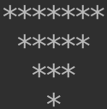

print("*******\n *****\n ***\n * ")

Input
Input function is used to store the value enter by the program’s user.

Name = input("What is your name?")
x = Name
print ("Your name is "+x+".")

What is your name? Faraz
Your name is Faraz.

In a .py file, create a program and use input() three times to get answers to the following questions from a user. Store each of the answers in a variable.
- What is your name?
- What is your quest?
- What is your favorite color?
Then, concatenate everything into a string within a print() statement with the form "So your name is [name], your quest is [quest], and your favorite color is [color]."

name = input("What is your name?")
quest = input("What is your quest?")
color = input("What is your favorite color?")
print("So your name is " + name + ", your quest is " + quest + ", and your favorite color is " + color + ".")

int() and float()
- The way string function allows you to change a number to a string, the integer and float functions allow you to turn strings into numbers.
x = input("Please enter a number: ")
y = int(x)
print(y)

Please enter a number: 84
84

x = input("Please enter a number: ")
y = float(x)
print(y)

Please enter a number: 84
84.0

Int() Exercise
In a Python file, use input() to ask the user to enter an integer that 10 will be added to. Assign what they type to a variable. print() the sum of the integer they entered and 10.

x = input("Enter the number: ")
print(type(x))
x = int(x)
y = x + 10
print(y)

Enter the number: 15
<class ‘str’>
25

Functions
Functions in python allows you to:
- Functions allows you to write block of codes once and use it many times.
- don’t need to repeat yourself.
- Reduces the length of code.
- Easier to maintain.
- Function can call other functions.
- Must be defined before the use.
- Has parameter support.
- Suppose, there is a piece of code that you want to run multiple times.
- You could do that by copying and pasting the code as many times as you need it to run, but that would require many lines of code.
- The main point of functions is to give programmers the ability to avoid having to duplicate code again and again.

Ex.:

def faraz():
print("Hello Faraz")
print("How are you?")
print("What's going on?")
faraz()

Hello Faraz
How are you?
What's going on?

Functions with parameters
def faraz(x):
print(x+2)
faraz(8)

10

Here, x is parameter.

Functions with multiple parameters
first = "The number "
def function(p1, p2, p3):
print(p1 + str(p2) + p3)
function(first, 5, " is an integer.")

The number 5 is an integer.

Here, p2 which 5 is an integer, therefore, in print function, you had to mention that 5 is a string.

Default Parameters
def x(num1=7, num2=8):
print(num1 * num2)
x()

56

- Here, parameter num1 is given the default value of 7 and parameter num2 is given the default value of 8.

- If you wil write
def x(num1=7, num2=8):
print(num1 * num2)
x(2)

16

Because, in x(2) 2 is the balue of num1 and 2*8 is 16.
Same way, if you had written,
- If you wil write
def x(num1=7, num2=8):
print(num1 * num2)
x(4,6)

24

because now, the program will consider that num1 = 4 and num2 = 6.
Return
- If we just want the output value but do not print it now, we can use return function.

def x(num1=7, num2=8):
return (num1 * num2)
print (x() + 44)

100

function with no parameters exercise
Do all of this in a .py file in Pycharm.
1. Create a function called hello_world_printer() which takes no parameters and prints the string "hello world"
2. Call the function hello_world_printer()

def hello_world_printer():
print ("hello world")
hello_world_printer()

function with 1 parameter exercise
Do all of this in a .py file in Pycharm
1. Create a function called name_printer which takes 1 parameter and prints it.
2. Create a variable called name and assign it user input(). input()'s message should ask the user to enter their name.
3. Call name_printer() with the variable "name" as its argument.

def name_printer(user_name):
print(user_name)
name = input("What is your name: ")
name_printer(name)

Programming Challenge: Celsius to Fahrenheit
The formula for converting from degrees Celsius to degrees Fahrenheit is as follows:
F = 1.8 * C + 32
Where F is the Fahrenheit temperature and C is the Celsius temperature.
In a .py file, create a variable and assign it an integer representing a celsius temperature that is entered as user input(). Input()'s message should prompt the user to enter an integer value.
For this programming challenge, you will then write a function called fahrenheit that takes in an integer representing a Celsius temperature as its argument. The function will return the Fahrenheit equivalent temperature of that argument to 1 place after the decimal.
At the end of your program, display the Fahrenheit equivalent in a print statement message formatted like so: "The Fahrenheit equivalent of [user entered integer] degrees Celsius is [number returned by function]".
To make sure that the function works, run your program multiple times and call the function on different user entered integer values both negative and positive.
x = input("Enter How Much Degree: ")
y = int(x)

def fahrenheit(cel):
return (18 * cel + 320) / 10

print("The Fahrenheit equivalent of " + str(y) + " degrees Celsius is " + str(fahrenheit(y)))

Intriduction to Modules
- Modules contain sets of functions that can be useful for many different things.
- To use the functions within them, you must import them.
- There are three different ways to do this:
1. Generic import
2. Function import
3. Universal import

Generic import:
- In the below example, the module being imported is the module random. Random is a module which contains functions for creating random things such as random floats or integer values.

import random
print(random.randint(1,10))

- You must call it by typing the module name which is random period . then the function called with whatever arguments it is supposed to take between its parentheses which is randint.
- The function Randint takes two integers as arguments and returns a random integer using them as the inclusive bottom and top of the range of integers that can be returned.
- This means that the integer returned will be greater than or equal to the first argument and less than or equal to the second argument.
- Sometimes, the output will be: 8
- Sometimes, the output will be: 7
- Sometimes, the output will be: 9
- Sometimes, the output will be: 5
and sometimes, the output will be: 4

- But, it will be greater than or equal to the 1 and less than or equal to 10.

Function Import
- A function import is when a specific function is imported from a module.
-To import a function from a module, you must type from the name of the module that the function is being imported from random Import then the name of the function being imported. In this example, the randint function is being imported from the random module.
- Let's use it to generate a random integer from the inclusive range between 10 and 20.

from random import randint
print(randint(10,20))

- Sometimes, the output will be: 18
- Sometimes, the output will be: 17
- Sometimes, the output will be: 19
- Sometimes, the output will be: 15
and sometimes, the output will be: 14

- But, it will be greater than or equal to the 10 and less than or equal to 20.

Universal Import
- A universal import is when you import every function from a module so that whenever you call any function from that module, you do not need to type the module's name and a period.
- To do a universal import, you simply type from the name of the module whose contents you want to import. Import. Then finally, an asterisk.
- Since in this example, every function from the random module has been imported, you can call and use any of its functions without having to type random and a period before using them.

from random import *
print(random())

- Sometimes, the output will be: 0.654657655
- Sometimes, the output will be: 0.35465754
- Sometimes, the output will be: 0.37453756376
- Sometimes, the output will be: 0.1324454874754355734
and sometimes, the output will be: 0.86734523643

Programming Challenge: Miles Per Gallon
For this exercise, you will create a program that approximates the number of miles per gallon that a car gets.
In a .py file, create two variables, one which will hold a randomly generated integer between 10 and 25 (inclusive of both 10 and 25), and another which will hold a randomly generated integer between and inclusive of 200 and 400. The first variable represents the number of gallons of gas that the car's fuel tank holds. The second variable represents the miles that the car can travel on a full tank before needing a refuel.
Using the formula miles per gallon (MPG) = miles driven/gallons used, calculate the car's MPG and display it in the output using print(). Use floor division instead of regular division for this calculation to get an integer instead of a float. This will give a realistic approximation of miles per gallon even though floats such as 19.8 round down a large amount when using floor division since sometimes, car manufacturers sometimes exaggerate miles per gallon. In addition, display the values held in the variables you created for gallons of gas in the car's fuel tank and miles it can travel on a full tank with two different print statements.

from random import randint
fuel = randint(10, 25)
miles = randint(200, 400)
print(" The number of gallons of gas " + str(miles // fuel))
print(" The miles that the car can travel on a full tank" + str(fuel))

Variable Scope
- In Python, you can have a variable within a function that has the same name as a variable outside of that function.
- However, despite having the same name, those variables are not the same variable.
- To understand how this works, you need to learn about global and local scope.
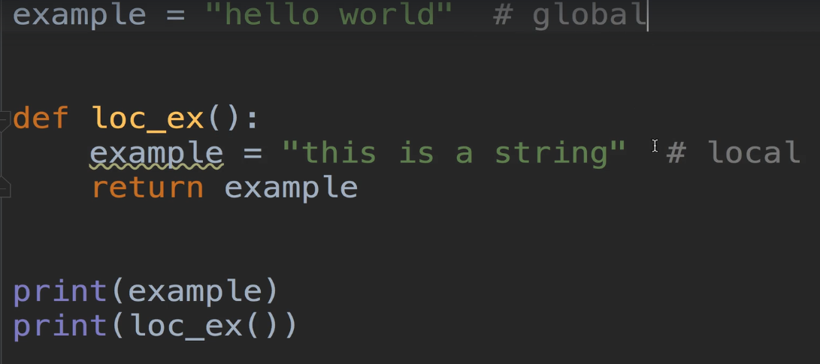
- So for this example, the first variable is in the global scope and so are the two print statements at the bottom.
- This is because none of them are within function definitions. Everything inside of the function lock is in a local scope.
- That means that the variable and return statement contained by loc_ex are both in a local scope. The local scope of the function loc_ex.
- You can also think of scopes as areas where variables are contained.
- This is because a variable in the global scope is known as a global variable, and a variable from a function's local scope is known as a local variable.
- All variables are either a global variable or a local variable, meaning one variable can't be a global variable and a local variable at the same time.
- The global scope is created when a program is run and is destroyed when the program ends.
- A local scope is created whenever a function is called, and all of the variables created within that function is called exist within that local scope.
- When a function call ends, which is after it returns something, the local scope of the function being called is destroyed and the local variables within it are forgotten.
- There are four points that you should know about variable scope so that you have a good idea of why understanding variable scope is important:
1. Local variables cannot be used by code in the global scope.

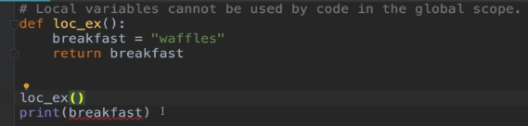
- This code won’t work.

2. Global variables can be accessed by code in a local scope.

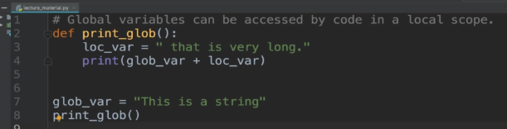
- This code will work.
3. Code in the local scope of one function can't use variables from another function's local scope.
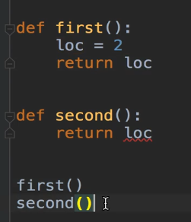

- This code won’t work.

4. you can use the same name for different variables as long as they are in different scopes.
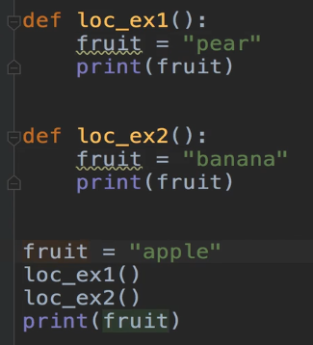

- This code will work.

Examples and their outputs:
1.
words = "hello world"

def hi_world():
return words

print(hi_world())

O/P:
hello world

2.
def pi_returner():
approx = 3.14
return approx

print(pi_returner())

O/P:
3.14

3.
def float_holder():
flo = 21.9
return flo
float_holder()
print(flo)

O/P:
It will display an error message.

4.
an_int = 50

def inty():
an_int = 100
return an_int

print(inty())

O/P:
The program will print 100.

5.
an_int = 50

def inty():
an_int = 100
return an_int

print(an_int)

O/P:
It will print 50.

Intro to flow control
- In this lecture, you will learn about basic flow control concepts like comparison operators and boolean operators.
- Before we learn operators, we will learn about flowcharts.
- A flow chart is a type of diagram which has a starting point and which can have multiple end points.
- It can have multiple end points because there are different paths that can be taken from the starting point depending on conditions which have different results.
- Flowcharts are a good analog to how code can execute within your programs.

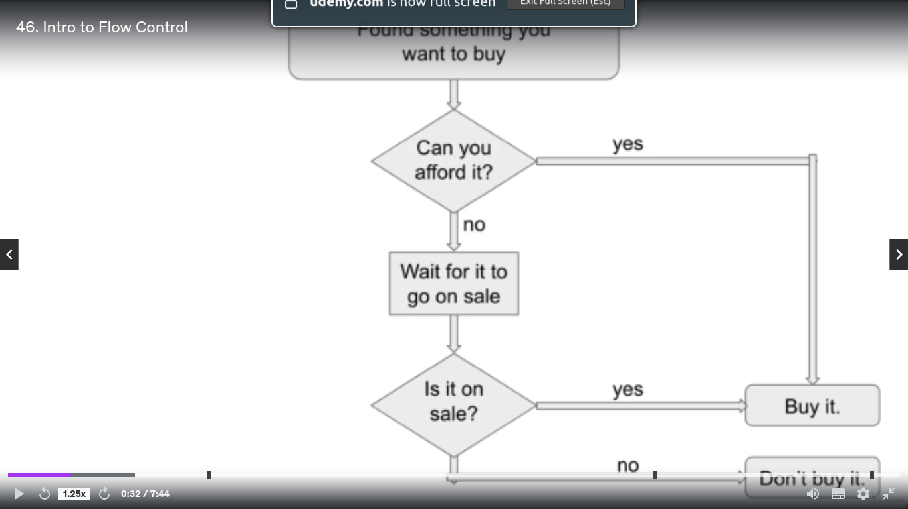

Operators
There are six operators:
1. > (Greater than)
2. < (Less than)
3. >= (Greater than or equal to)
4. <= (Less than or equal to)
5. != (Not equal to)
6. == (Is equal to)

- Comparisons made using these operators evaluate to a boolean value meaning that comparisons result in either a true or false.
- The greater than comparison operator returns true if the value to the left of it is greater than the value to the right of it.
Ex.
print (4 > 2)
True

- In this example, the first print statement resulted in true since 4 is greater than 2.

Same way,
print (4 == 4)
True

print(5.79 < 6)
True

print(3 < 3)
False

print(9 >= 9)
True

print(1 <= 2)
True

print(10 != 100)
True

print(10 != 10)
False
print ("Hello" == "Hello")
True

print ("Hello" != "World")
True

print (4 == 4.0)
True

print (4 >= 4.0)
True

and operators
- Both the conditions must be True to get the True as an output.
True and True True
True and False False
False and False False
False and True False

Ex.
print (4>1 and “word” == “word”)
True

print(8.76 == 8.7600 and 2 != 2)
false

or operators
- Any one condition is True the output will be True
True or True True
True or False True
False or False False
False or True True

Ex.
print (4>1 or “word” == “word”)
True

print(8.76 == 8.7600 or 2 != 2)
True

not operator
- If the condition is False not will make is True. Same way,
if the condition is True not will make is False
not True False
not False True

Ex.
print (not 6480 < 0)
True

print (not “Python” != “Python”)
False

What is the operator that is used to check if two things are identical?
==

What comparison operator is used to check if something is not equal to something else?
!=

What are the two comparison operators that are used to represent less than and greater than?
< and >

What are the two comparison operators that are used to represent less than or equal to and greater than or equal to?
<= and >=

What does True and False evaluate to?
False

What does print("PIZZA" == "pizza" or 100 == 100.00) evaluate to?
True

What comparison operators out of the 3 options available should be used in place of the question marks for this not True ? False and "green" ? "red" to evaluate to True?
== and !=

If statements
x = input("Enter your favourite sweet: ")
if x == "Gulab Jamun":
print("You are legened")

You are legened

Else statement
x = input("Enter your favourite sweet: ")
if x == "Gulab Jamun":
print("You are legened")
else:
print("You are ordinory!")
Nested if and else statement
gpa = float(input("What was applicant\'s gpa?: "))
inst_app = input("Is the student is going to be educated at an approved institute?: ")
if gpa >= 3.8:
if inst_app == "yes":
print ("The applicant qulifies for the loan!")
else:
print("The applicant does not qualify")
else:
print("The applicant do not have enough grades!")

Programming Challenge: Grade Determiner
Professor Fuentes teaches a Python class and uses the following grading scale for all of her exams. You work as a teacher's assistant and due to her busy schedule she has requested that you write a program which will determine the grades of the class's students.
Her grading scale is as follows:
- A score of 90 or above is an A
- A score of 80 or above is a B
- A score of 70 or above is a C
- A score of 60 or above is a D
- A score any lower is an F
For this exercise, start by creating a variable and assigning that variable a student's score as an integer using input().
Then, using nested if and else statements and the following set of rules, determine and then display the student's grade along with their score using print().
- If the student's score is greater than or equal to 90, then the student will receive an A grade.
- Otherwise, if the student's score is greater than or equal to 80, then the student will receive an B grade.
- Otherwise, if the student's score is greater than or equal to 70, then the student will receive an C grade.
- Otherwise, if the student's score is greater than or equal to 60, then the student will receive an D grade.
- Otherwise, the student will receive an F grade.
Make sure to run your program multiple times and test it with values for each 5 of the different grades to make sure that the correct output is displayed for any value entered as a student's score.

score = int(input("Please enter the student's score. "))

if score >= 90:
print("This student's score of " + str(score) + " is an A.")
else:
if score >= 80:
print("This student's score of " + str(score) + " is a B.")
else:
if score >= 70:
print("This student's score of " + str(score) + " is a C.")
else:
if score >= 60:
print("This student's score of " + str(score) + " is a D.")
else:
print("This student's score of " + str(score) + " is a F.")

Elif statement
user_num = int(input("Please enter an integer: "))
if user_num < 0:
print("The number you entered is less than 0")
elif user_num == 0:
print("The number you enterd is 0")
elif 0 < user_num <= 100:
print("The number you entered can be 1, 100 or anything in between")
else:
print("The number you entered is greater than 0")

Truthy and Falsy Value

string_example = input("Enter any string other than empty numner: ")
if string_example:
print("Thankyou for entering something!")
else:
print("You did not enter a string!")

bool()
print(bool(0))
False

print(bool(400))
True
print(bool(3.14159))
True

print(bool("Hello World!"))
True

While loop
- Loops are a useful tool for when you want to have code run on every item in a piece of data that has indexes such as a string.
- Here, we will learn about a type of loop known as a while loop.

counter = 0
while counter < 3:
print("something")
counter += 1

O/P:
something
something
something

However,

counter = 1
while counter < 6:
print("something")

Above command will run the infinite number of times and eventually crash the code.

While Loops Exercise
For this exercise, you will print 10 descending integers starting from 10 and ending at 1 with each integer being 1 less than the last and each integer printed on a new line.
Create a variable and assign it the integer 10.
Then, print
10
9
8
7
6
5
4
3
2
1
in the output by using a while loop to print numbers while the variable does not equal 0. Use the -= operator to reassign descending values to the variable.

counter = 10
while counter >= 1:
print(counter)
counter -= 1

For loops
word = "House"
for letter in word:
print(letter)

H
o
u
s
e

For Loops Exercise
Use a for loop to print each letter from the string "hello world".
word = "Hello world"
for letter in word:
print(letter)

range()
- Range is a function that returns a sequence of numbers and is usually used for iterating over with a for loop.
- It can take three arguments, start, stop, and step, and can be used with one, two, or all three of them at the same time.

one_input = range(5)
for num in one_input:
print(num)

O/P:
0
1
2
3
4

one_input = range(10)
print(type(one_input))
<class ‘range’>

Using range() with two arguments

two_inputs = range(5,10)
for num in two_inputs:
print(num)
O/P:
5
6
7
8
9

Using range() with three arguments
three_inputs = range(1,20,3)
for num in three_inputs:
print(num)

O/P:
1
4
7
10
13
16
19

What numbers are in the range(): range(3)
0, 1 and 2

What numbers does the range() range(11, 16) consisit of?
11, 12, 13, 14 and 15

What numbers are in the range() below?
Range(10, 25, 5)
10, 15 and 20

What are the numbers that make up the range()?
Range (6, -1, -2)
6, 4, 2 and 0

Programming Challenge: Fizz Buzz
Write a program that iterates over the integers 1 through 50 using a loop.
However, for numbers which are multiples of both 3 and 5 print “FizzBuzz” in the output. For example, 15 is divisible by both 3 and 5, so instead of printing 15, print "FizzBuzz". For numbers which are multiples of 3 but not 5 (such as 42) print “Fizz” instead of the number. For the numbers that are multiples of 5 but not 3 (such as 20) print “Buzz” instead of the number.
All of the integers which are not multiples of 3 or 5 should just be printed as themselves.
for num in range(1, 51):
if num % 3 == 0 and num % 5 == 0:
print("FizzBuzz")
elif num % 3 == 0:
print("Fizz")
elif num % 5 == 0:
print("Buzz")
else:
print(num)

String Methods 1
- String methods are functions that are built into Python, which allow you to perform useful operations with strings such as splitting them or changing their case so that they can be used as part of non case sensitive comparisions with othe strings.
Upper and lower string methods:

all_low = "There are no capitals here."
print(all_low.upper())
O/P:
THERE ARE NO CAPITALS HERE.

all_up = "THERE ARE NO CAPITALS HERE."
print(all_up.lower())
O/P:
there are no capitals here.

print("MIXED CASE".isupper())
True

print("Mixed Case".isupper())
False

Multiple String Methods
print("shout".upper())
SHOUT

.isalpha() Only letters
.isalnum() Only numbers and letters
.isdecimal() Only numbers
.isspace() Only spaces
.istitle() Only titlecase

print("Batman".isalpha())
True

print("Batman123".isalnum())
True

print("123".isdecimal())
True

print("3.14".isdecimal())
False

print(“ ”.isspace())
True

print(“The Empire Strike Back”.istitle())
True

print("the great faraz".title())
The Great Faraz

print("this is a string".startswith("this"))
True

print("this is a string".endswith("string"))
True

print("".join(["one","two","three"]))
onetwothree

print(" ".join(["one","two","three"]))
one two three

print(", ".join(["one","two","three"]))
one, two, three

print("Eggs, Milk, Waffles, Bacon".split())
[‘Eggs,’ ‘Milk,’, ‘Waffles,’, ‘Bacon’]
String Methods 2
.rjust() and .ljust():

print("hello world".rjust(15))
hello world

print("hello world".ljust(15) + "four spaces later.")
hello world four spaces later.

print("hello world".center(15))
hello world

.replace()
print("Good Morning!".replace("Morning", "Afternoon"))
Good Afternoon

len()
print(len("Faraz"))
5

.format()
name = input("What is your name?")
degree = input("What did they major in?")
job = input("What is the current occupation?")
experience = input("How many years of experience do you have?")
print("{} majoured in {}, works as a {}, and has {} years of experience.".format(name, degree, job, experience))

Faraz majoured in EC, works as a DevOps, and has 5 years of experience.

Lists
print(list("blast"))
[‘b’, ‘l’, ‘a’, ‘s’, ‘t’]

checked_list = [1, 2, 3, 4]
print(1 in checked_list)
True

checked_list = [1, 2, 3, 4]
print(8 in checked_list)
False

Indexes and list slicing
Index_Example = ["carpet","hardwood", "linoleum"]
print(Index_Example[0])
carpet

Index_Example = ["carpet","hardwood", "linoleum"]
print(Index_Example[1])
hardwood

Index_EXample = [[1,2,3],[4,5,6],[7,8,9]]
print(Index_EXample[2][0])
7

Index_Example = ["carpet","hardwood", "linoleum"]
print(Index_Example[2][0])
l

Negative Indexes
negative = [1,2,3,4,5]
print(negative[-1])
5

Using items accessed by indexes in expressions:

mixed = [False, 365, 4.24, "This is a string"]
print(mixed[2] + 1.76)
6.0

List Slicing
sliced = [1,2,3,4,5,6,7,8,9]
print(sliced[:4])
print(sliced[3:8])
print(sliced[6:])

O/P:
[1,2,3,4]
[4,5,6,7,8]
[7,8,9]

example = [2,4,6,8,0]
print(example)
example[3] = 10
print(example)

O/P:
[2,4,6,8,0]
[2,4,6,10,0]

del and list methods
planets = ["pluto", "mars", "earth", "venus"]
del planets[0]
print(planets)
["mars", "earth", "venus"]

.remove()
planets = ["pluto", "mars", "earth", "venus"]
planets.remove("pluto")
print(planets)
["mars", "earth", "venus"]

.append()
pets = ["cat", "dog", "parrot"]
pets.append("fish")
print(pets)
["cat", "dog", "parrot", "fish"]

.insert()
pets = ["cat", "dog", "parrot"]
pets.insert(1, "fish")
print(pets)
["cat", "fish", "dog", "parrot"]

.sort()
num_list=[2.718, 4, -19, 1000, 0]
num_list.sort()
print(num_list)
[-19, 0, 2.718, 4, 1000]

str_list = ["Ringo", "John", "George", "Paul"]
str_list.sort()
print(str_list)
['George', 'John', 'Paul', 'Ringo']

ASCII = ["Andy", "Kiwi", "apple", "Karen", "Brian", "banana"]
ASCII.sort()
print(ASCII)
['Andy', 'Brian', 'Karen', 'Kiwi', 'apple', 'banana']
.index()
metals = ["copper", "gold", "silver", "iron"]
print(metals.index("silver"))
2

Lists vs String
- A list and a string both contain an ordered sequence of items.
- In addition, several things that can be done with strings can also be done with lists.
- Because both of them have index numbers corresponding to what they contain, you can access their contents by index, get slices from them, use the length function to get the number of characters or items that they contain, and you can even iterate through either of them using a for loop or a while loop.
- The important distinction between lists and strings is that lists are mutable while strings are immutable.
- For a data type to be mutable means that it can have values be changed, removed, or added.
- The values of immutable data types cannot be changed in any way.

Lists = Mutable
Strings = Immutable

ex_3 = "No, you can't."
ex_4 = "Yes" + ex_3[3:11] + "!"
print(ex_4)
Yes you can!

References
ex_5 = 3.14
ex_6 = "coconut"
ex_7 = ex_5
ex_8 = ex_6
print(ex_7)
print(ex_8)
3.14
coconut

Why does python have references?
- Well, the reason is that lists can be, and are often much bigger than the lists shown in the examples in this course, such as the last example which was made up of just five numbers.
- Lists that small only take up a small amount of computer memory. Imagine if instead of puny lists like those shown in this course so far, you had a list with the names of all of the items in the inventory of a huge supermarket chain like Walmart or just a list with the subtotals of every transaction made in a year by just one of its stores.
- Working with lists that large, which could have tens of thousands to millions of items would be a huge problem for computer memory if they're used multiple times and copied and stored in memory every time they're used.

copy module and deepcopy()
import copy
ex_12 = [1,2,3,4,5]
ex_13 = copy.deepcopy(ex_12)
print(ex_12)
print(ex_13)
[1,2,3,4,5]
[1,2,3,4,5]

Introduction to dictionaries
- Dictionaries are a data type which can store a collection of values like a list.
- A dictionary is different from a list in that instead of having to have each of its items be assigned to an index number that is an integer, the items that a dictionary contains are assigned to keys which can be different data types such as floats and strings.
- Let’s go over to see how to create a dictionary:
- To create a dictionary, you start by typing curly brackets. Then in the curly brackets, you type key value pairs.
- A key value pair consists of a key and a value separated by a colon and a space.

console = {"nintendo": "wii", "microsoft": "xbox", "sony": "playstation"}
print(console["microsoft"])
xbox

Dictionaries are unordered.

first = {0:2.1, 1:2.2, 2:2.3, 3:2.4}
second = {2:2.3, 0:2.1, 3:2.4, 1:2.2}
print (first == second)
True

In and not in
first = {0:2.1, 1:2.2, 2:2.3, 3:2.4}
print (0 in first)
True

first = {0:2.1, 1:2.2, 2:2.3, 3:2.4}
print (5 not in first)
True

Dictionary Methods 1: .keys(), .values(), .items() and .get()
.keys():
birth_year = {1994: "bill", 1969: "emily", 1982: "elizabeth", 2000: "turner"}
print(birth_year.keys())

dict_keys([1994, 1969, 1982, 2000])

birth_year = {1994: "bill", 1969: "emily", 1982: "elizabeth", 2000: "turner"}
for key in birth_year.keys():
print(key)
1994
1969
1982
2000

.values():
birth_year = {1994: "bill", 1969: "emily", 1982: "elizabeth", 2000: "turner"}
for values in birth_year.values():
print(values)
bill
emily
elizabeth
turner

.items():
birth_year = {1994: "bill", 1969: "emily", 1982: "elizabeth", 2000: "turner"}
print(birth_year.items())
dict_items([(1994, 'bill'), (1969, 'emily'), (1982, 'elizabeth'), (2000, 'turner')])

birth_year = {1994: "bill", 1969: "emily", 1982: "elizabeth", 2000: "turner"}
for key, value in birth_year.items():
print(key, value)

1994 bill
1969 emily
1982 elizabeth
2000 turner

Using in and not in
birth_year = {1994: "bill", 1969: "emily", 1982: "elizabeth", 2000: "turner"}
print ("elizabeth" in birth_year.values())
True

.get()
birth_year = {1994: "bill", 1969: "emily", 1982: "elizabeth", 2000: "turner"}
print (birth_year.get(1975, "1975 is not a key in birth_years"))

1975 is not a key in birth_years

birth_year = {1994: "bill", 1969: "emily", 1982: "elizabeth", 2000: "turner"}
print (len(birth_year))
4

.fromkeys()
ex_1 = {}.fromkeys("ad", "1600 Pennsylvania avenue NW")
print(ex_1)
{'a': '1600 Pennsylvania avenue NW', 'd': '1600 Pennsylvania avenue NW'}

ex_1 = {}.fromkeys(["brand"])
print(ex_1)
{‘brand’: None}

.pop()
ex_2 = {"make": "Honda", "model": "civic", "year": 2016}
ex_2.pop("model")
print(ex_2)
{"make": "Honda", "year": 2016}

Dictionary method 3: .clear(), .copy() and .update()
ex_1 = {1: "England", 2: "Scotland", 3: "Wales", 4:"Norhern Island"}
print(ex_1)
ex_1.clear()
print(ex_1)

{1: 'England', 2: 'Scotland', 3: 'Wales', 4: 'Norhern Island'}
{}

birth_year = {1994: "bill", 1969: "emily", 1982: "elizabeth", 2000: "turner"}
print(birth_year)
people=birth_year
people[1982] = "madeline"
print(birth_year)
{1994: 'bill', 1969: 'emily', 1982: 'elizabeth', 2000: 'turner'}
{1994: 'bill', 1969: 'emily', 1982: 'madeline', 2000: 'turner'}

Dictionary method 4: .setdefault()
computers = {"Google": "Chromebook", "Apple": "Macbook", "Microsoft": "Windows"}
if "Lenovo" not in computers:
computers["Lenovo"] = "Thinkpad"
print(computers)
{'Google': 'Chromebook', 'Apple': 'Macbook', 'Microsoft': 'Windows', 'Lenovo': 'Thinkpad'}

computers = {"Google": "Chromebook", "Apple": "Macbook", "Microsoft": "Windows"}
computers.setdefault("Lenovo", "Thinkpad")
print(computers)
{'Google': 'Chromebook', 'Apple': 'Macbook', 'Microsoft': 'Windows', 'Lenovo': 'Thinkpad'}

empty = dict()
print(empty)
with_values = dict(a=1, b=2, c=3)
print(with_values)
{}
{'a': 1, 'b': 2, 'c': 3}

